Dajarra State School Newsletter
Term 1, Week 2

Welcome Back
Welcome back to a new school year. It was great to see our student attend last week. They were excited to be back and meet their teachers.

This year Deb Robinson has joined our teaching team and will be in the Year 3- 6 class. Lis Carlson will take the Kindy – Year 2 class. Liz and Deb will be out about this week meeting all our families and catching up with you all. If you have any questions please contact your child’s teacher or the office.

2021 Enrolments: Queensland State Schools report their enrolment numbers on day 4 (1st of Feb) and Day 8 (Friday 8th Feb). These numbers inform the state and the region and provide our funding for the year. It is very important that all our students attend school to ensure that our numbers are accurate. Also, if there are any other students that you know that will be attending our school this year, please contact the office immediately so we can enrol them.

100 Year Celebration. I have recently had a number of enquiries as to when this will go ahead this year. The pavers have been ordered and should arrive late February or early March. Next Wednesday 10th Feb at 2:30 will be a community meeting to discuss the celebrations. A note will go home later this week with more information. Please share this meeting with others in the community and come along to help us.
Lastly, students absent from school. Please be aware that it is a requirement that your child attends school regularly. In addition, there needs to be a valid reason for your child to be absent. At the end of last year, we had many students regularly away without valid reasons. If your child has is not at school regularly and without a valid reason, I will be contacting parents to discuss these.
Have a great week
Zoe Hall

At a glance

Term 1

Week 2
1st-2nd Kindy Days
4th Playgroup- Louise
9:30-11am

Week 3
8th-10th Kindy Days
11th Playgroup- Louise 9:30-11am
12th Playgroup- Sally

10th Community Meeting – 100 Year Celebration @ 2:30

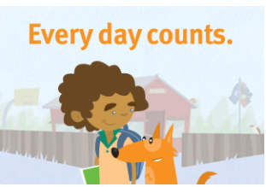

School website: dajarrass.eq.edu.au/
What's Happening This Term – Red= new entry
Week | Monday | Tuesday | Wednesday | Thursday | Friday
1 | 25/01/2021 | 26/01/2021 | 27/01/2021 | 28/01/2021 | 29/01/2021
 | Student free day | Australia Day | Kindy
2 | 1/02/2021 | 2/02/2021 | 3/02/2021 | 4/02/2021 | 5/02/2021
 | Kindy | Kindy |  | Playgroup- Louise 9:30-11
3 | 08/02/2021 | 09/02/2021 | 10/02/2021 | 11/02/2021 | 12/02/2021
 | Kindy | Kindy | Kindy | Playgroup- Louise 9:30-11 | Sally-Playgroup
4 | 15/02/2021 | 16/02/2021 | 17/07/2021 | 18/02/2021 | 19/02/2021
 | Kindy | Kindy |  | Playgroup- Louise 9:30-11
5 | 22/02/2021 | 23/02/2021 | 24/02/2021 | 25/02/2021 | 26/02/2021
 | Kindy | Kindy | Kindy | Playgroup- Louise 9:30-11 | Sally-Playgroup
6 | 01/03/2021 | 02/03/2021 | 03/03/2021 | 04/03/2021 | 05/03/2021
 | Kindy | Kindy |  | Playgroup- Louise 9:30-11
7 | 08/03/2021 | 09/03/2021 | 10/03/2021 | 11/03/2021 | 12/03/2021
 | Kindy | Kindy | Kindy | Playgroup- Louise 9:30-11 | Sally-Playgroup
8 | 15/03/2021 | 16/03/2021 | 17/03/2021 | 18/03/2021 | 19/03/2021
 | Kindy | Kindy |  | Playgroup- Louise 9:30-11
9 | 22/03/2021 | 23/03/2021 | 24/03/2021 | 25/03/2021 | 26/03/2021
 | Kindy | Kindy | Kindy | Playgroup- Louise 9:30-11
10 | 29/03/2021 | 30/03/2021 | 31/03/2021 | 01/04/2021 | 02/04/2021
 | Kindy | Kindy |  |  | Good Friday

FREE COMMUNITY EVENT
Playgroup Qld invites children 4 years and under to come along to participate in many activities that promote play and learning.
DAJARRA STATE SCHOOL
Every Thursday 9:30am-11:00am: with Miss Louise
28 January 2021
4 February 2021
11 February 2021
18 February 2021
25 February 2021
4 March 2021
11 March 2021
18 March 2021
25 March 2021
1 April 2021
Every 2nd Friday 9:30am-11:00am: with Miss Sally and Donna
12 February 2021
26 February 2021
12 March 2021
Any enquires please don’t hesitate to contact us on 47484914.
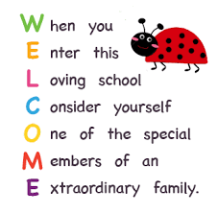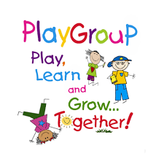

What’s happening in K-2 class

Welcome back to all our junior students. This year our room looks a little different and we are happy to share it with our kindy friends. Our little superheroes have hit the ground running with some deadly counting, learning about data and exploring characters in stories. Pig the Pug, our naughty dog is by far the most popular character. For Science, we will be working about the weather and features in our environment. Miss Louise and I are always happy to have a chat and our doors are always open if you would like to come and have a look at the deadly learning your child is doing here.
Kindly,
Miss Liz and Miss Louise.
